|  |  |
| --- | --- |
| *Thema: Potenzfunktionen mit natürlichen Exponenten* | **AB 1** |

**1**a) Zeichne die Graphen der Funktionen mit den Gleichungen

    in das Koordinatensystem ein. Verwende verschiedene Farben.



b) Vergleiche die Eigenschaften der Funktionen und ihrer Graphen miteinander.

Ergänze die Tabelle.

|  |  |
| --- | --- |
| **Eigenschaften** | **Funktionsgleichung** |
| Die Graphen sind achsensymmetrisch zur *y*-Achse. |  |
| .............................................zum Koordinatenursprung | ;; |
| Definitionsbereich |  |
| Wertebereich |  |
| Der Graph verläuft durch den Punkt . |  |
| Der Graph verläuft durch die Punkte  und | ; |
| Der Graph verläuft durch die Punkte  und | ;; |
| Die Funktion ist monoton steigend für . |  |
| Die Funktion ist monoton fallend für .................... | ; |

c) Bestimme für alle Funktionen die Funktionswerte zu   .

|  |  |  |  |  |  |  |  |  |  |  |  |  |  |  |  |  |  |  |  |  |  |  |  |  |  |  |  |  |  |  |  |
| --- | --- | --- | --- | --- | --- | --- | --- | --- | --- | --- | --- | --- | --- | --- | --- | --- | --- | --- | --- | --- | --- | --- | --- | --- | --- | --- | --- | --- | --- | --- | --- |
|  |  |  |  |  |  |  |  |  |  |  |  |  |  |  |  |  |  |  |  |  |  |  |  |  |  |  |  |  |  |  |  |
|  |  |  |  |  |  |  |  |  |  |  |  |  |  |  |  |  |  |  |  |  |  |  |  |  |  |  |  |  |  |  |  |
|  |  |  |  |  |  |  |  |  |  |  |  |  |  |  |  |  |  |  |  |  |  |  |  |  |  |  |  |  |  |  |  |
|  |  |  |  |  |  |  |  |  |  |  |  |  |  |  |  |  |  |  |  |  |  |  |  |  |  |  |  |  |  |  |  |
|  |  |  |  |  |  |  |  |  |  |  |  |  |  |  |  |  |  |  |  |  |  |  |  |  |  |  |  |  |  |  |  |
|  |  |  |  |  |  |  |  |  |  |  |  |  |  |  |  |  |  |  |  |  |  |  |  |  |  |  |  |  |  |  |  |

d) Ermittle für alle Funktionen, an welchen Abszissen die Ordinate jeweils den Wert 2 besitzt.

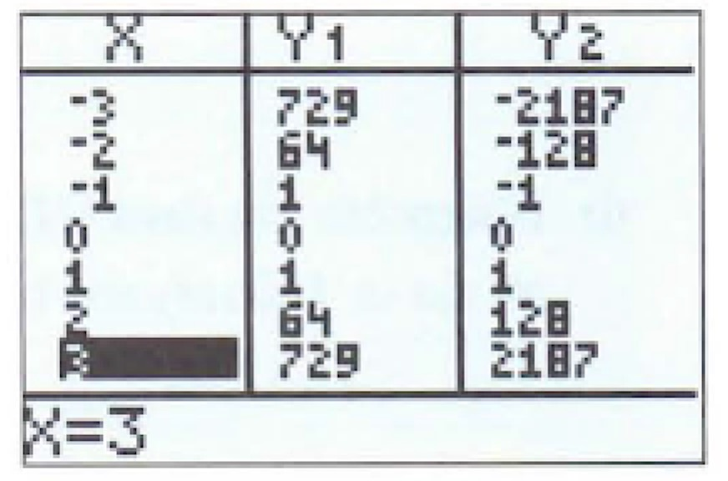

|  |  |  |  |  |  |  |  |  |  |  |  |  |  |  |  |  |  |  |  |  |  |  |  |  |  |  |  |  |  |  |  |
| --- | --- | --- | --- | --- | --- | --- | --- | --- | --- | --- | --- | --- | --- | --- | --- | --- | --- | --- | --- | --- | --- | --- | --- | --- | --- | --- | --- | --- | --- | --- | --- |
|  |  |  |  |  |  |  |  |  |  |  |  |  |  |  |  |  |  |  |  |  |  |  |  |  |  |  |  |  |  |  |  |
|  |  |  |  |  |  |  |  |  |  |  |  |  |  |  |  |  |  |  |  |  |  |  |  |  |  |  |  |  |  |  |  |
|  |  |  |  |  |  |  |  |  |  |  |  |  |  |  |  |  |  |  |  |  |  |  |  |  |  |  |  |  |  |  |  |
|  |  |  |  |  |  |  |  |  |  |  |  |  |  |  |  |  |  |  |  |  |  |  |  |  |  |  |  |  |  |  |  |
|  |  |  |  |  |  |  |  |  |  |  |  |  |  |  |  |  |  |  |  |  |  |  |  |  |  |  |  |  |  |  |  |
|  |  |  |  |  |  |  |  |  |  |  |  |  |  |  |  |  |  |  |  |  |  |  |  |  |  |  |  |  |  |  |  |

**2**a) Lies aus den Wertetabellen rechts die Symmetrieeigenschaften der Graphen ab.

..............................................................................................

b) Finde die zugehörigen Funktionsgleichungen:

.............................................................................................